**TUTORIAL-1**

Q:1 What does LAMP stand for?

Ans:- The LAMP stack is a collection of open-source technologies commonly integrated to create a platform capable of supporting a wide variety of Web applications. LAMP typically consists of Linux, Apache Tomcat, MySQL, and either the PHP, Python or Perl scripting languages.

Q:2 Why various companies becoming cloud computing providers?Give suitable reasons.

Ans:-

1. Cost savings

By outsourcing your cloud managed services, you control and reduce costly network maintenance costs. Staffing a full-time IT department is expensive and often unnecessary for small to medium-sized businesses with simple networks. Outsourcing to a cloud-first managed services provider like Agile IT can save you thousands each year on the cost of an in-house IT department.

2. Predictable, recurring monthly costs

With the flexibility of cloud managed services, you decide how much you’re willing to pay for IT services and have a consistent monthly bill.For example, a tax service has a spike in customers during tax season and will need more support during the first quarter of the year and less during the second through fourth quarters. A privatized learning institute for working adults will need the most support in the evenings when students are online after work.With afixed monthly service plan that’s customized to fit your needs or budget, you optimize the amount you pay for IT support.

3. Future-proofed technology

Migrating to a cloud environment is the first step in future-proofing your data center. Next, you’ll need make the latest technology and services available to your business.By hiring an in-house IT staff, your IT personnel will have to spend company time training when a new technology or required upgrade gets released. Cloud technicians are already prepared to manage the latest technology.

4. Custom and integrated service

Cloud managed service providers are flexible. Some providers offer pay-per-service or payment plans, enabling your business tofocus funds on growth.Other cloud managed service providers offer a converged solution, which produces even more cost savings. These converged solutions may include security protection, network monitoring or the setup of a new service area.

### **5. Robust infrastructure**

Cloud MSPs like Agile IT offer a robust network infrastructure with 24/7 management. Depending on the service agreement, a cloud managed service provider can monitor and scan the network for patch requirements security, and more.Managed service providers can also integrate existing business practices and policies to manage your network to coincide with your organizational goals.

### **6. Centralized network services and applications**

With a managed cloud network, the provider manages all applications and servers in a central data center.

This increased network availability also raises employee production. Your remote network users can access centralized data within the same network including virtual services, and you can build storage and backup into a centralized network.

### **7. Coverage on all service levels**

Cloud service providers offer better control over service levels, performance and maintenance. With a comprehensive service-level agreement, your business gains service continuity. The longer you work with a cloud managed services provider like Agile IT, the more familiar they become with your network, leading to faster issue response times.

### **8. Disaster recovery**

Services are the lifeline of a cloud managed service provider. Agile IT has designed countless networks and data centers with proven redundancy and resiliency to maintain business continuity.With cloud managed services, your data will be safe and secured across all cloud services and applications. In the event of a disaster, your business and operations can continue with minimal downtime.

### 9. Fast response times

Your businesses can expect quick response times through enterprise-level monitoring and remote cloud services. Agile IT can access, monitor and repair virtually any network issue remotely. If you must resolve an issue locally, a technician should be dispatched within the same business day.

### 10. Vendor interfacing

When vendor-specific service issues arise, cloud managed service providers take care of contacting third-party vendors to resolve them.As a certified Microsoft consulting partner and 4-time Microsoft Cloud Partner of the Year, Agile IT understands the technical questions to ask when communicating issues with cloud vendors including Microsoft and Amazon.At Agile IT, we are committed to helping businesses leverage custom cloud solutions to control costs and automate critical processes. As a cloud managed services provider, we set up, manage and protect your cloud environment so you can focus on growing your business.

Q:3- How Virtualization differ from cloud computing?

|  |  |  |
| --- | --- | --- |
| **Characteristics** | **Virtualization** | **Cloud Computing** |
| **Definition** | Technology | Methodology |
| **Purpose** | Create multiple simulated environments from 1 physical hardware system | Pool and automate virtual resources for on-demand use |
| **Use** | Deliver packaged resources to specific users for a specific purpose | Deliver variable resources to groups of users for a variety of purposes |
| **Configuration** | Image-based | Template-based |
| **Lifespan** | Years (long-term) | Hours to months (short-term) |
| **Cost** | High capital expenditures (CAPEX), low operating expenses (OPEX) | Private cloud: High CAPEX, low OPEX  Public cloud: Low CAPEX, high OPEX |
| **Scalability** | Scale up | Scale out |
| **Workload** | Stateful | Stateless |
| **Tenancy** | Single tenant | Multiple tenants |

# **TUTORIAL-2**

Oues. What is hypervisor?Difference between the type 1 and type 2 hypervisor? Find out examles of each hypervisor?

Ans. A hypervisor is a function which abstracts -- isolates -- operating systems and applications from the underlying computer hardware. This abstraction allows the underlying [host machine](https://searchservervirtualization.techtarget.com/definition/host-virtual-machine-host-VM)hardware to independently operate one or more [virtual machines](https://searchservervirtualization.techtarget.com/definition/virtual-machine) as guests, allowing multiple guest VMs to effectively share the system's physical compute resources, such as [processor](https://whatis.techtarget.com/definition/processor)cycles, memory space, network bandwidth and so on. A hypervisor is sometimes also called a virtual machine monitor.

Hypervisors provide several benefits to the enterprise [data center](https://searchdatacenter.techtarget.com/definition/data-center). First, the ability of a physical host system to run multiple guest VMs can vastly improve the utilization of the underlying hardware. Where physical (nonvirtualized) servers might only host one operating system and application, a hypervisor virtualizes the server, allowing the system to host multiple VM instances -- each running an independent [operating system](https://whatis.techtarget.com/definition/operating-system-OS)and application -- on the same physical system using far more of the system's available compute resources.

VMs are also very mobile. The abstraction that takes place in a hypervisor also makes the VM independent of the underlying hardware. Traditional software can be tightly coupled to the underlying server hardware, meaning that moving the application to another server requires time-consuming and error-prone reinstallation and reconfiguration of the application. By comparison, a hypervisor makes the underlying hardware details irrelevant to the VMs. This allows any VMs to be moved or migrated between any local or remote [virtualized servers](https://searchnetworking.techtarget.com/definition/virtual-server) -- with sufficient computing resources available -- almost at-will with effectively zero disruption to the VM; a feature often termed *live migration*.

VMs are also logically isolated from each other -- even though they run on the same physical machine. In effect, a VM has no native knowledge or dependence on any other VMs. An error, crash or malware attack on one VM does not proliferate to other VMs on the same or other machines. This makes hypervisor technology extremely secure.

### Types of hypervisors

Hypervisors are traditionally implemented as a software layer -- such as [VMware vSphere](https://searchvmware.techtarget.com/definition/VMware-vSphere) or Microsoft Hyper-V -- but hypervisors can also be implemented as code embedded in a system's firmware. There are two principal types of hypervisor.

Type 1 hypervisors are deployed directly atop the system's hardware without any underlying operating systems or other software. These are called ["bare metal"](https://searchservervirtualization.techtarget.com/definition/bare-metal-hypervisor) hypervisors and are the most common and popular type of hypervisor for the enterprise data center. Examples include vSphere or Hyper-V.

Type 2 hypervisors run as a software layer atop a host operating system and are usually called "hosted" hypervisors like VMware Player or Parallels Desktop. Hosted hypervisors are often found on endpoints like PCs.

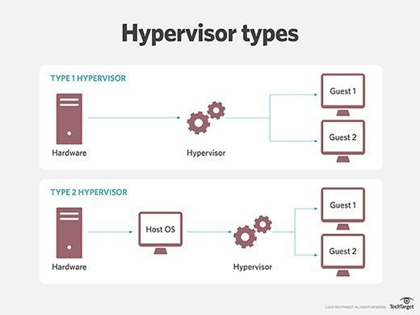

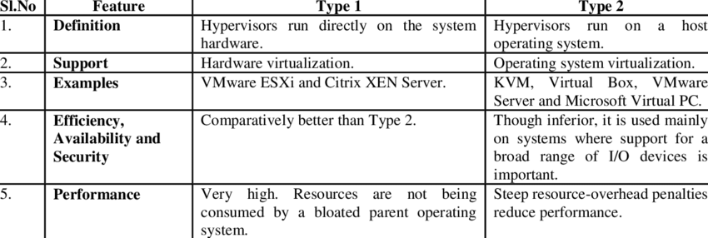

**TUTORIAL – 3**

Q1. Describe Infrastructure as a Service cloud computing model. Diagrammatically show a virtual privet server partitioned in an Iaas cloud with three workloads and briefly explain the same.

Ans.

* 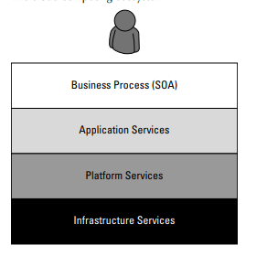You can broadly partition cloud computing into four layers that form a cloud computing ecosystem, as shown in Figure. The Application layer forms the basis for Software as a Service (SaaS), while the Platform layer forms the basis for Platform as a Service (PaaS) models that are described in the next two sections. Infrastructure as a Service (IaaS) creates what may be determined to be a utility computing model, something that you can tap into and draw from as you need it without significant limits on the scalability of your deployment. You pay only for what you need when you need it. IaaS may be seen to be an incredibly disruptive technology, one that can help turn a small business into a large business nearly overnight. This is a most exciting prospect; one that is fueling a number of IaaS startups during one of the most difficult recessions of recent memory.
* Infrastructure as a Service (IaaS) is a cloud computing service model in which hardware is virtualized in the cloud. In this particular model, the service vendor owns the equipment: servers, storage, network infrastructure, and so forth. The developer creates virtual hardware on which to develop applications and services. Essentially, an IaaS vendor has created a hardware utility service where the user provisions virtual resources as required.
* The developer interacts with the IaaS model to create virtual private servers, virtual private storage, virtual private networks, and so on, and then populates these virtual systems with the applications and services it needs to complete its solution. In IaaS, the virtualized resources are mapped to real systems. When the client interacts with an IaaS service and requests resources from the virtual systems, those requests are redirected to the real servers that do the actual work.
* The fundamental unit of virtualized client in an IaaS deployment is called a workload. A workload simulates the ability of a certain type of real or physical server to do an amount of work. The work done can be measured by the number of Transactions Per Minute (TPM) or a similar metric against a certain type of system. In addition to throughput, a workload has certain other attributes such as Disk I/Os measured in Input/Output Per Second IOPS, the amount of RAM consumed under load in MB, network throughput and latency, and so forth. In a hosted application environment, a client’s application runs on a dedicated server inside a server rack or perhaps as a standalone server in a room full of servers. In cloud computing, a provisioned server called an instance is reserved by a customer, and the necessary amount of computing resources needed to achieve that type of physical server is allocated to the client’s needs.
* Figure shows how three virtual private server instances are partitioned in an IaaS stack. The three workloads require three different sizes of computers: small, medium, and large.

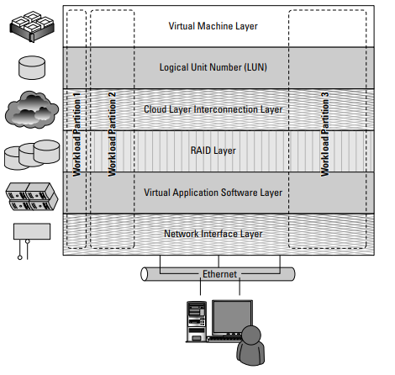

A virtual private server partition in an IaaS cloud

* The classic example of an IaaS service model is Amazon.com’s Amazon Web Services (AWS). AWS has several data centers in which servers run on top of a virtualization platform (Xen) and may be partitioned into logical compute units of various sizes. Developers can then apply system images containing different operating systems and applications or create their own system images.

**TUTORIAL 4**

Q1.

Abbreviate and define CCIF in Cloud Computing.

Ans

**CCIF** stands for Cloud Computing Interoperability Forum.

Interoperability within the context of Cloud Computing means enabling the Cloud Computing Ecosystem whereby individuals and organisations are able to widely adopt Cloud Computing technology and related services in such a fashion that multiple Cloud platforms can exchange information in a unified manor and ultimately work together seamlessly,

The Cloud Computing Interoperability Forum (CCIF) was formed in order to enable a global cloud computing ecosystem whereby organizations are able to seamlessly work together for the purposes for wider industry adoption of cloud computing technology and related services. A key focus will be placed on the creation of a common agreed upon framework / ontology that enables the ability of two or more cloud platforms to exchange information in an unified manor.

CCIF is an open, vendor neutral, not for profit community of technology advocates, and consumers dedicated to driving the rapid adoption of global cloud computing services. CCIF shall accomplish this by working through the use open forums (physical and virtual) focused on building community consensus, exploring emerging trends, and advocating best practices / reference architectures for the purposes of standardized cloud computing.

Q2.

Name the standards used for providing

a. Infrastructure portability solution

b. Application portability solution

Ans

**a)** The CloudWATCH2 Consortium, that is operating in the Horizon 2020 framework, issued a series of guides for the use of standards in order to facilitate an approach to Interoperable and Secure Cloud Services that avoids vendor lock-in (in particular for SMEs and procurers). Other standards that could be referred to, or that are useful for standardising cloud computing interoperability and portability, have already assessed by CAMSS.

**b)** Cloud application portability mitigates the risk of vendor lock-in and ensures that the SaaS application is built over open standards and is portable on most cloud operating platforms. Whether in a traditional model, or a cloud model, vendors of software obviously want to lock-in clients. Given that a big part of the cloud computing model is about freeing an organization from proprietary infrastructure, it only makes sense that open standards are desirable. In practice however, portability is always more complex.

**Tutorial 5**

Q 1) Define the term Virtual Appliance?

A virtual appliance (VA) is a virtual machine (VM) image file consisting of a pre-configured operating system (OS) environment and a single application. The purpose of a virtual appliance is to simplify delivery and operation of an application. To this end, only necessary operating system components are included.

A virtual appliance can be deployed as a VM or a subset of a virtual machine running on virtualization technology, such as VMware Workstation. Deploying an application as a virtual appliance can eliminate problems with installation and configuration, such as software or driver compatibility issues. Users can simply download a single file and run the application. Resources required for maintenance are also reduced. Virtual appliances have proven useful in deploying network applications. They are also helpful in grid computing, where they can solve problems introduced by heterogeneous hardware and operating systems, and in the Software as a Service (Saas) delivery model, where the simplicity of the virtual appliance can help improve economies of scale.

There are two types of virtual appliances, closed and open. A closed VA is always packaged, distributed, maintained, updated and managed as a unit. An open VA is accessible to customers for modifications. Developers can include a Web interface for custom configurations or delivering patches and updates.

Q 2) Write about the various services provided by IBM Cloud?

1. Manage IT complexity and harness the speed of technology innovation

2. Cloud Services

3. Business Resiliency Services

4. Technology Support Services

5. Network Services

6. Digital Workspace Services